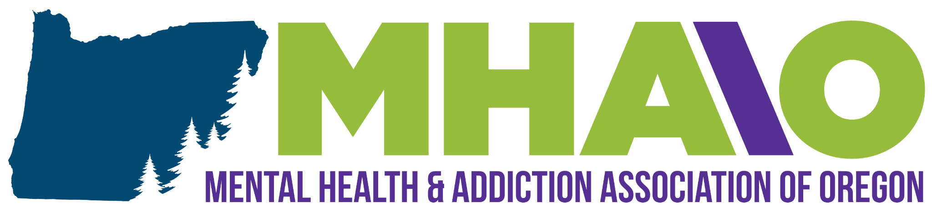
Additional Resources: Module Three
Budgeting Resources:
- Tips for Creating a Budget
- Free Online Budgeting Tools
- Apps That Help You Budget
- Free Budget Worksheets & Spreadsheets
- Budgeting Information
- How to Create a Successful Budget
- How to Create a Budget in 6 Steps

Online Budgeting Worksheets:
- Nerd Wallet’s Free Budget Worksheet
- Google Sheets Budget Template

Tips for Saving Money
- 100 Ways to Save Money
- 10 Easy Ways to Save Money
- 190 Resources for Saving Money
- 99 Ways to Save
- Easy Money Saving Resources
- Life Hacks for Saving Money
- 11 Frugal Living Tips

Resources for Saving Money
- Resources for Utility Bill Assistance
- FDIC Savings-Related Resources
- Homeownership & Low-Incomes
- How to Find Affordable Rental Housing
- How to Pay Off Your Mortgage Quickly
- Weatherization & Energy-Saving Resources
- Home Energy Saving Tips
- How LED Lights Can Save You Money
- Apply for Reduced Wifi

Social Security & Disability Resources & Benefits
- How to File for SSI and SSDI If Homeless
- Financial Resources & Support for People With Disabilities
- What is a PASS? Social Security Administration
- The Social Security Administration
- How to Apply for SSDI & SSI
- Eligibility for Disability Benefits
- SSI/SSDI Outreach For People With Mental Health/Addiction Challenges (SAMHSA)

State & Federal Resources
- Veteran’s Benefits
- Applying for Food, Medical, or Child Care Benefits (in Oregon)

